Assignment 1 - Theory Part (HTML Module )

## Defining The Terms

### **Website**

The website is the platform where the company puts all types of relevant information about its products, services, contact details, and third-party collaborations. In technical terms, the website is the collection of different web pages which has the same domain name and are hosted on at least one web server. The information will be shown on the world wide web.

**Webpage**

a webpage can be regarded as a set of documents that are coded with HTML for the world wide web. All the web pages are identified by URL (uniform resource locator).

**Web Browser**

With the help of web browsers, users can easily navigate the information and content present on the world wide web. On pasting the URL of a particular website on a web browser, it sends the request to the server, which ultimately sends back the reflected web page. Lastly, the browser responds and renders the displays on your device’s screen.

### **Web Server**

The major function of the web server is to deliver web content such as website pages, and information to the client devices over the internet. The web servers are remote databases that are fully responsible for receiving requests from the web browsers, processing them, and sending them back to the client devices. Some of the most common examples of web servers are - Apache HTTP Server, Ngnix, Microsoft Internet Information Services, etc.

### **HTML**

HTML stands for “Hyper Text Markup Language”. It is the skeleton of any document on a webpage. Fundamentally, HTML is a client-side scripting language. Additionally, markup represents all the changes that are made by the author and will be directly visible to the clients as well. The current version of HTML is 5 with modifications in the boilerplate code and media tags.

### **CSS**

CSS means “Cascading Style Sheets” which are used for giving designs and other functionalities to elements of the HTML skeleton. Styling can be done in three ways namely - Inline CSS, External CSS, and Internal CSS.

## **Integration of CSS**

CSS can be integrated in three ways. These are mainly with the help of “Inline CSS, External CSS, and Internal CSS. Now, I'll be defining each one of them one by one -

* **Inline CSS** - in this form, the whole CSS is written inside the element of the tag. All you have to do is just type the attribute “style” and start writing the code. For example - style = “font-size: 34px” and much more.

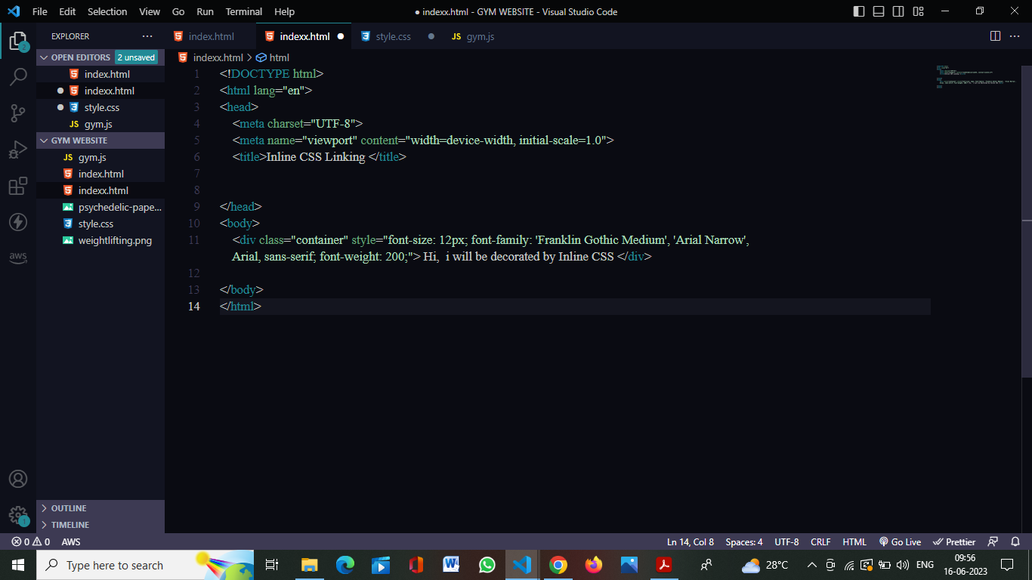

* **Internal CSS** - in this form, the CSS is written under the style tag. Interestingly, the <style> tag is placed just below the <title> tag of the html document. Now, there are some rules to write internal CSS. Some common are giving each one of your elements a “class” or an “id” and calling them in the stylesheet. For example -

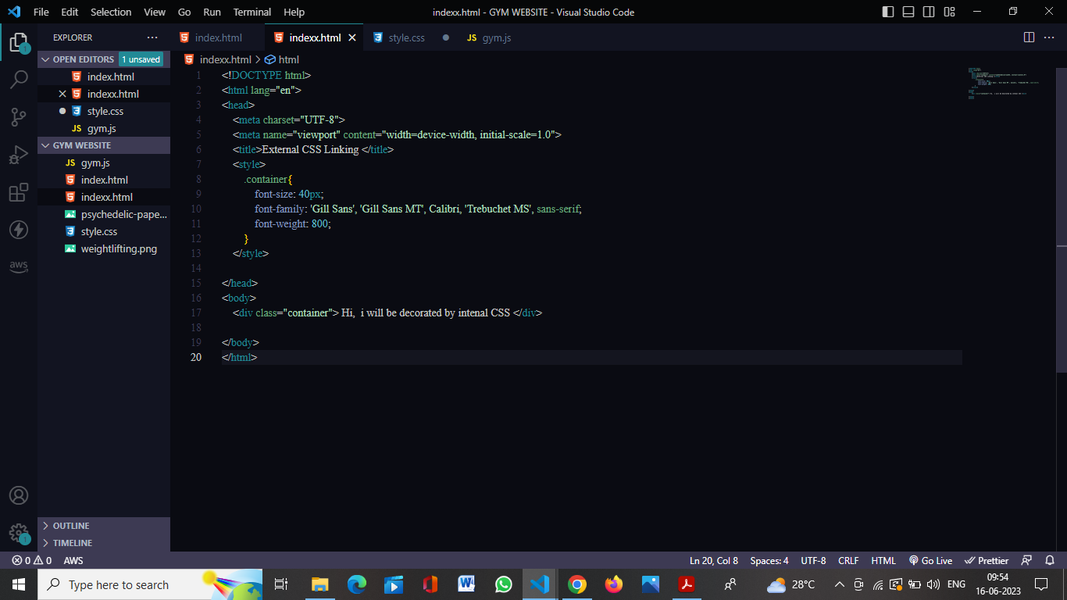

* **External CSS** - this is the form of writing CSS in the most comfortable way. Most of companies prefer writing CSS externally. For this, all you have to do is create a file with the extension (.css). For example - “style.css”. This will create a separate stylesheet for you and you can link this sheet at the top of your html document. Here’s an image provided for your reference.

